**ANTI - CHEATING TOOL FOR GAMING TOURNAMENT**

**(TEZOS BLOCKCHAIN)**

[**PROJECT NAME – FIXCHEAT**]

***Abstract******: The*** problem of cheating in online games is increasing at an alarming rate. Cheaters use a variety of methods to gain an unfair advantage over other players, including using exploits, bots, and hacks. This not only ruins the experience for other players, but also undermines the integrity of the game itself. This paper is about how we can use **tezos** blockchain to prevent cheating and this paper is also about how we can use cheating pattern and store them on tezos blockchain and prevent future cheatings and how to implement this idea easily.

***Keywords:*** blockchain, tezos, cheating, gaming, idea.

**1.What is the problem**

The issue of cheating in online gaming tournaments is a controversial one. Some people argue that cheating is a problem that needs to be addressed, while others believe that it is not a big issue. There are a few reasons why cheating might occur in online gaming tournaments. First, cheating can give a player an unfair advantage over his or her opponents. Second, cheating can be used to win prizes or money that are associated with the tournament. Finally, some people cheat in online gaming tournaments simply for the thrill of it. There are many ways to prevent cheating in gaming tournaments using tezos blockchain or any other. First, making a smart contract that collects proof of identity for participants. Second, A database of cheating pattern and store cheating pattern on blockchain and this pattern is accessible through smart contract and many more ways, but our idea base is set on second idea.

------------------------------------------------------------------------------------------------------------------------------------------

------------------------------------------------------------------------------------------------------------------------------------------

**2.**  **understanding tezos network.**

**Tezos** is a decentralized blockchain that enables users to submit and vote on proposals to upgrade the network. This enables a self-governing network where all stakeholders can contribute to its evolution. **Tezos** was founded by **Arthur Breitman**, a former hedge fund manager, and his wife Kathleen Breitman, a former senior product manager at Google. The couple met while working at the same hedge fund, where Arthur was a quantitative analyst and Kathleen was a trader. **Tezos** is built on a foundation of peer-to-peer (P2P) networking, cryptography, and **game theory**. It is these three elements that give **Tezos** its unique properties and advantages.

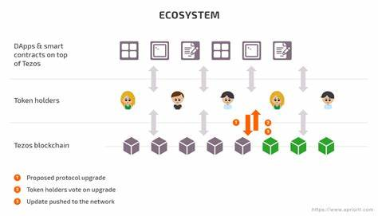

*Visualization of* ***tezos*** *blockchain*

*-------------------------------------------------------------------------------------------------------------------------------------------------------------------------------------------------------------------------------------------------------------------------------------*

***3.*My idea for** **anti-cheating tool**

* *Overview*

Our project name is **Fix-****cheat**, and this tool helps to developers for implementing anti cheating mechanism in his games this tool is powered by **tezos** blockchain and smart contracts. this tool is powe**rful for preventing cheatings in games**

* ***Description of this tool (Fix-cheat)***

**This tool (smart contract) can send out warnings to players if a pattern of cheating is detected. It can also remove players from the game if they continue to cheat after** **being warned. Example – spawn from** **nowhere, go through walls,** **consistently win, unlimited health,** **etc. This tool is basically a smart contract written in jsligo and this smart contract will allow to developer to set pattern of cheating and use for their game and this tool also** **have more feature like.**

* **The tool can identify patterns of cheating behavior in online gaming and report it to the gaming tournament host**
* **The tool can keep a** **record of the cheating patterns on tezos** **blockchain it has identified and help to prevent future cheating by flagging wallet** **addresses that match those patterns.**
* **The tool can be used to automatically ban players who are found to be cheating, or to warn them and give them a chance to reform.**
* **The tool can be used to investigate suspected cheating behavior and provide evidence to support bans or other disciplinary action.**

**----------------------------------------------------------------------------------------------------------------------------------------------------------------------------------**

**4. How does Fix-cheat** **works and how we use tezos blockchain**

Fix-cheat smart contract powered by tezos . Getting real time game data and player data from (GAME server) through API. This server monitors game data and player data in real time. Then fix-cheat smart contract looking to game data and tries to identify cheating pattern in gameplay. If smart contract finds cheating pattern, then player get warning for first through smart contract after this if users again try to cheat user will be banned. This way, the smart contract can effectively detect and prevent cheating in online games. By banning players who are caught cheating, the smart contract can help create a fair and balanced gaming environment for all players.

**Entrypoints samples**

**1.Setpattern() ------> allow game developer to set different cheating pattern in this smartcontract.**

**2.Blockuser() -------> allow developer to block user after max warnings.**

**3.Warnuser() --------> this use for sending warning to user.**

**4.Validatepattern() ---------> allow the developer to validate which cheating pattern used.**

**5.Blockedusers() -------> this function is used for get blocked user list and cheating pattern they used**

**6.Warnlimit() -------> to set warning limit after this limit user get automatically blocked**

**I *mentioned just some function but many more remains it just an example.***

-------------------------------------------------------------------------------------------------------------------------------------------------------

**DIAGRAM OF THIS IDEA**

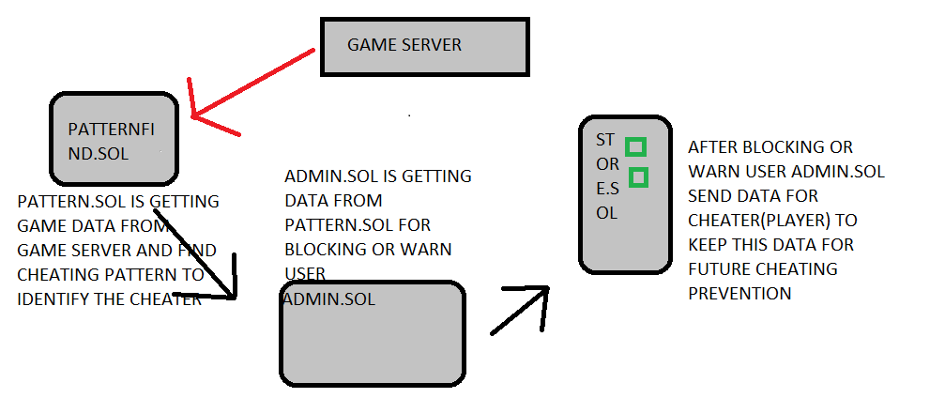

In this diagram you can see 4 smart contract which is part of this fix-cheat tool all 4 smart contract have their own importance

1. GAME server == this is not a smart contract this a server that monitor gameplay and send the gameplay data to pattern.sol .
2. PATTERN.SOL == this smart contract is used to identify cheating pattern from gameplay.
3. ADMIN.SOL == this smart contract is for setting cheating pattern and controlling all 2 smart contracts when this smart contract receive identified pattern then the smart contract send warning to user or block user.
4. STORE.SOL == this smart is used for storing blocked user wallet addresses and cheating pattern for future purpose

---------------------------------------------------------------------------------------------------------------------------------------------------------------

***END***